**Task 2: Figma Screens**

**The Figma Screens are done here in this file:**

1. **Screen 1: Homepage**



1. **Screen: Loading page**

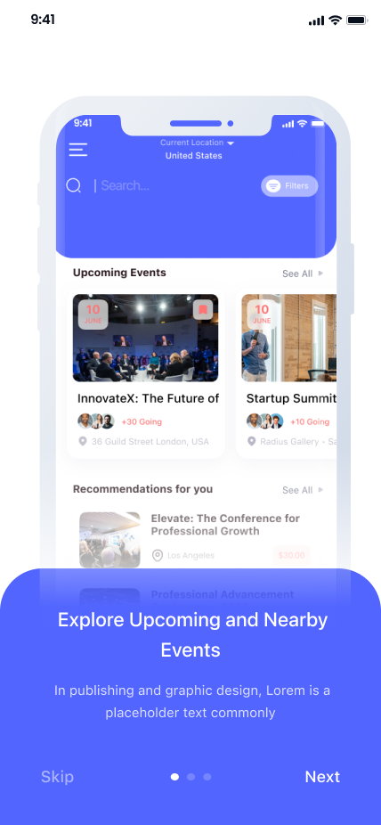

1. **Screen : Loading page1**

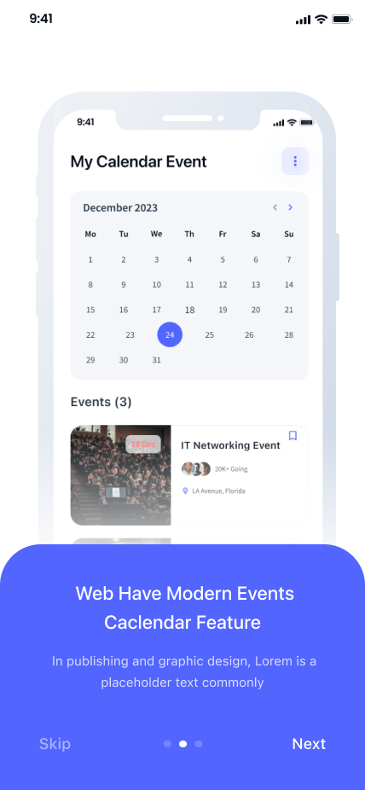

1. **Screen : Register**

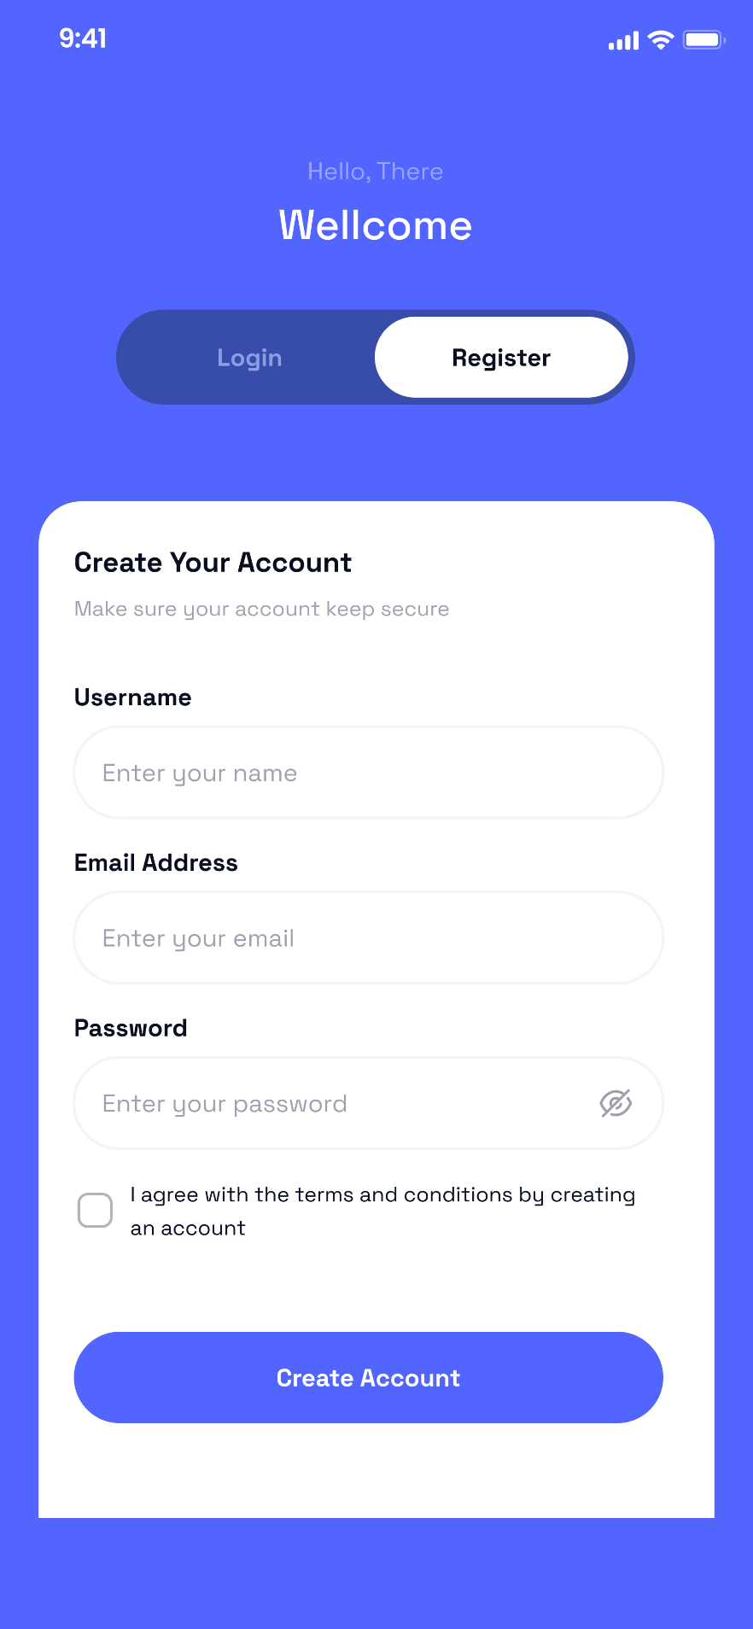

1. **Screen : Login**

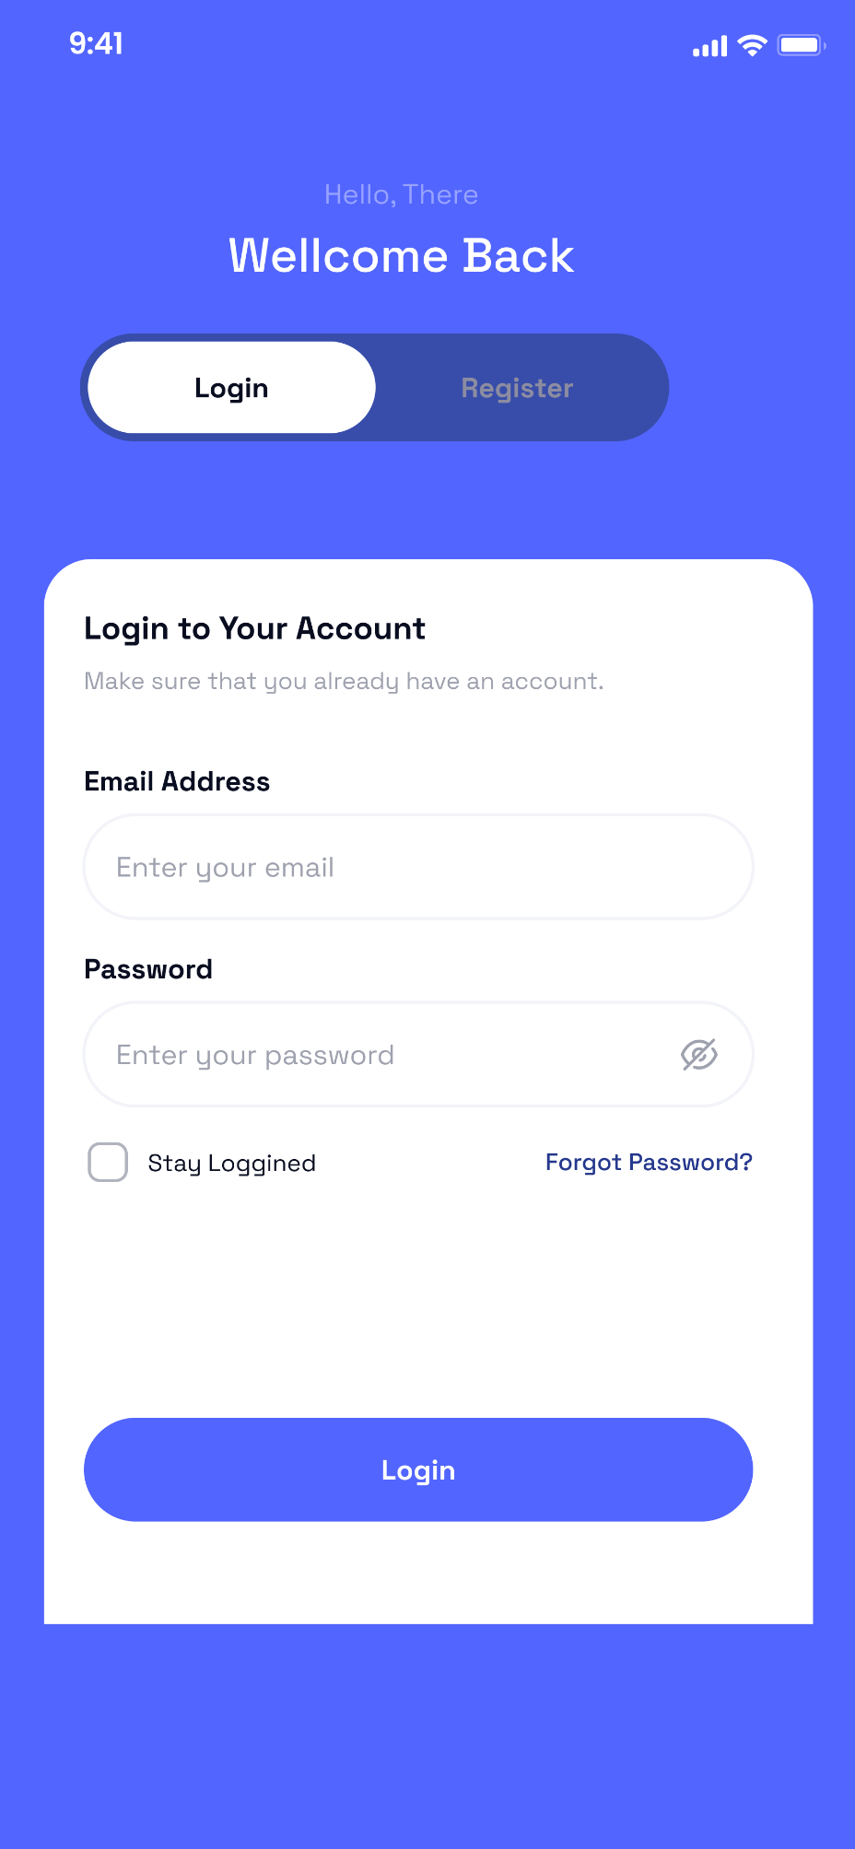

1. **Screen : Home Page**

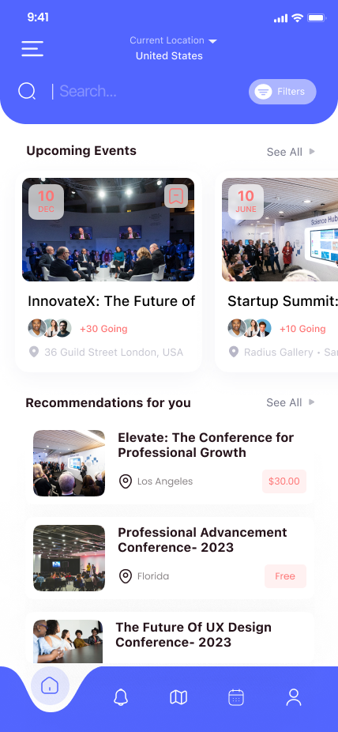

1. **Screen : Events Details**

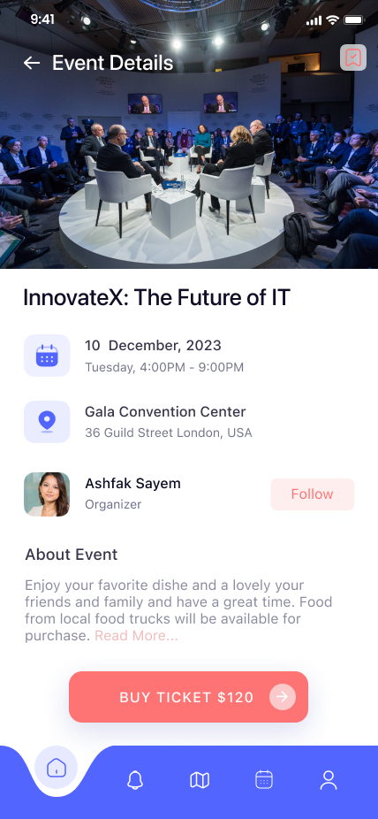

1. **Screen : Calendar Event Lists**

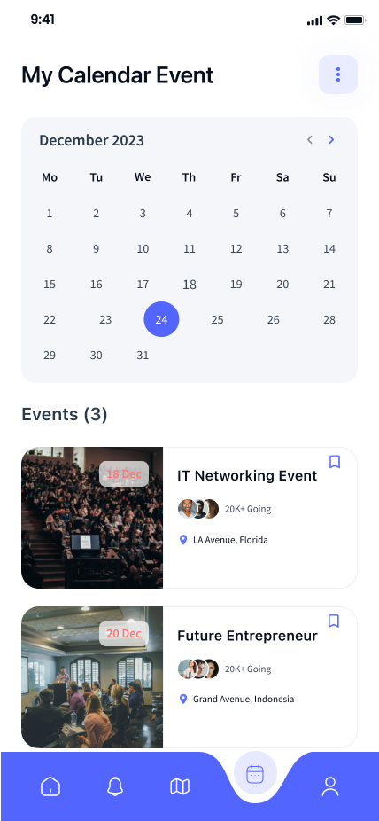

**Screen : 9 Empty Notifications**

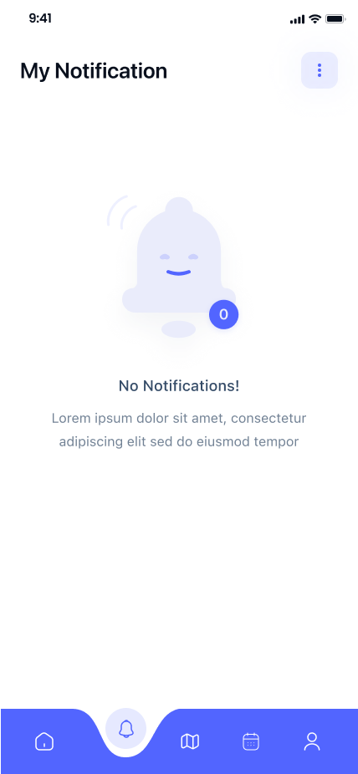

**These are all the screens used to make the website named Event Management.**

**To make the prototype for the website make it artistic, professional and design oriented.**